**Testimonial**

Back in 2017 when I was 53 years old, I was “slightly” over-weight at a trim 105 kg with a size 42-inch waist. I was curious about my health and weight. It seems that after 30 years old, I put on an average of 1.5 to 2 kg. My waistline also grew proportionally, despite been active and trying a lot of different diets. I also had more than a few health issues, including high blood pressure which was 145 over 95. When I hit my 50s, I sort of gave up and I did not think much about it or chose not to. Like a lot of my friends at that age, my philosophy in life back then was there’s nothing much we can do and just to let nature takes its course and live life to the fullest. I think it is a combination of denial and laziness. This is how I looked back then:

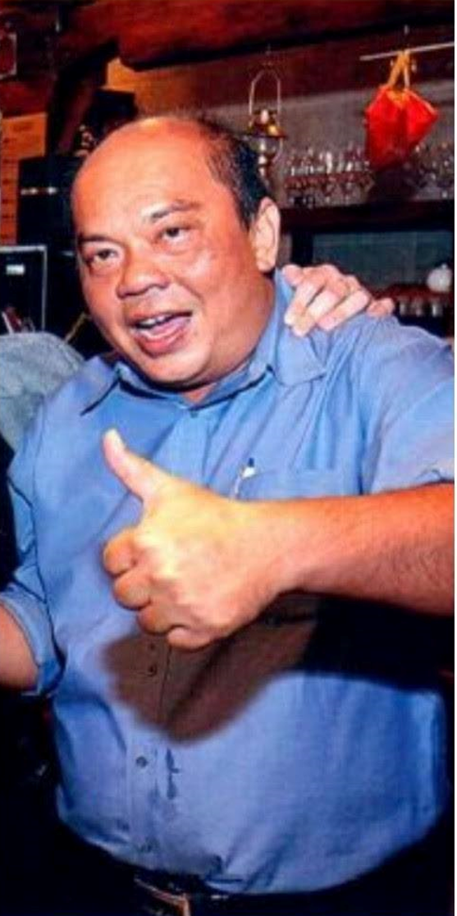

Fast forward to today and I have made tremendous improvement in both my weight and health issues. Recently, when I met some friends who hadn't seen me in a while, they couldn't help but notice the significant weight loss I had achieved. It was evident that a few of them even held a concern that I might be battling a serious illness, although they were too polite to inquire directly. I want to assure everyone that there is no need to worry. The reason behind my transformation is quite straightforward.

One day in early 2017, my childhood friend Low Chin Chau asked me out for breakfast. Breakfast soon became lunch and we spent 3 or 4 hours talking. Little did I know that this casual outing would turn into a transformative journey and be life-changing.

Chin Chau spent a lot of time explaining his health and wellness programme. But back then, I was very resistant. For those who knew me back then, you would know how “busy” I was to exercise. Diet was a bad word! Let’s be honest – I was absolutely lazy! I remember I used to drive to the 7-11 that was 100m down the road!

But thankfully, Chin Chau did not give up and before I knew it, I found myself agreeing to follow Chin Chau’s programme. Initially, it was just tweaking my diet by cutting sugar and reducing processed food and carbs. I was amazed that I lost 5kg in the 1st month!

I was very motivated and started speaking with Chin Chau whenever I could (or whenever he had the time). I discovered that there’s so much we have misunderstood on basic nutrition, exercise, even on the importance of sleep and generally our overall wellness. I am happy to report that today, I have lost at least 35 kg and 11 inches off my waist. Oh, and my blood pressure is in the low range (110 over 70).

This is how I look last year. I have never felt healthier or stronger in a long time. I am very glad and grateful that up to today, Chin Chau is still helping me and a small group of friends who joins him for calisthenics and weight training every week.

